Hoover First
United Methodist Church
Reaching out to all people,
inviting them to experience the love of Jesus Christ

Last Sunday after Pentecost
Novembehttps://cliphttps://clipartmag.com/images/christian-bulletin-clipart-18.jpgground.com/images/free-religious-clipart-new-year-6.jpgr 26th, 2023

July 7, 2024

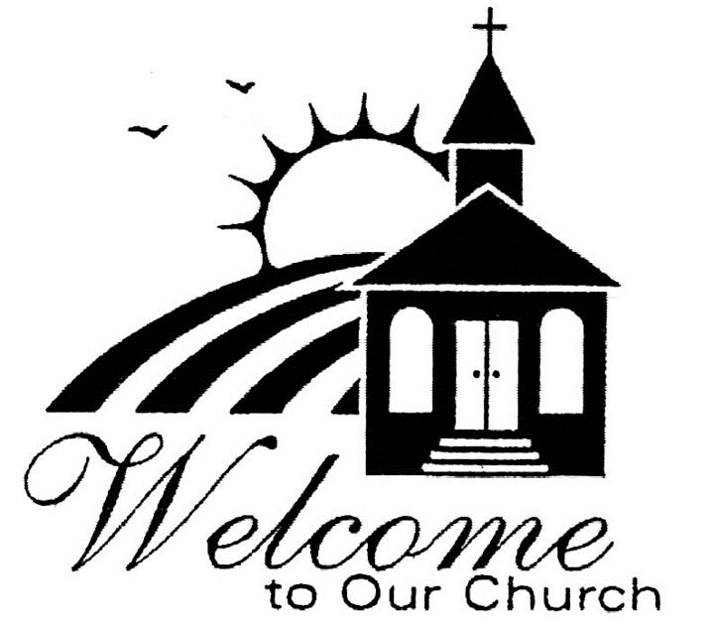

Church – 822-8099
Frances Gable – Business Manager, finance@hooverfirstumc.org Call/Text (205) 706-8106
Tammi Powell – Music Director, magicitymusicstudio@yahoo
Order of Worship

Prelude Hoover First Music Duo Tammi Powell, Flute and Connie Logan, Piano

Welcome and Announcements

Choral Call to Worship “Holy God, We Praise Thy Name”

(Congregation will stand as you are able for the first hymn, Affirmation of Faith and Gloria Patri.)

*Hymn of Praise “God, Whose Love is Reigning o’re Us” No. 100 (Verses 1,3,5)
*Affirmation of Faith “The Apostles’ Creed”
I believe in God the Father Almighty, maker of heaven and earth
and in Jesus Christ his only son our Lord; who was conceived by the
Holy Spirit, born of the Virgin Mary, suffered under Pontius Pilate,
was crucified, dead, and buried, the third day he rose from the dead;
he ascended into heaven, and sitteth at the right hand of God the
Father Almighty; from thence he shall come to judge the quick and
the dead. I believe in the Holy Spirit, the holy catholic church, the
communion of saints, the forgiveness of sins, the resurrection of the
body, and the life everlasting. Amen

*The Gloria Patri

Glory be to the Father and to the Son and to the Holy Ghost, as it was
in the beginning, is now and ever shall be, world without end. Amen. Amen.

(Congregation to be seated.)

*Hymn “Seek Ye First” No. 405
(Verses 1 & 2)
Sharing our Joys & Concerns

Choral Call to Prayer “ O Lord, Hear My Prayer”

Silent Meditation and Prayer

The Pastoral Prayer

The Lord’s Prayer

Our Father, who art in heaven, hallowed be thy name. Thy
kingdom come, thy will be done on earth as it is in heaven. Give
us this day our daily bread. And forgive us our trespasses, as we
forgive those who trespass against us. And lead us not into
temptation but deliver us from evil. For thine is the kingdom, and
the power, and the glory, forever. Amen

*Offering Announcement
We are not passing offering plates this morning. The offering plate is located at the back door and available for you to place your offering when you leave the sanctuary. During this time, you are encouraged and invited to please keep giving commitments current.

Choral Anthem “For the Beauty of the Earth” arr. J. Althouse The Chancel Choir, Tammi Powell, Director
Scripture

Sermon Rev. Katie Allred

*Hymn of Dedication “Lord, Whose Love Through Humble Service” No. 581
(Verses 1-4)
*Benediction

*Choral Response “ The Lord Bless You and Keep You”

*The Postlude

Our Prayers

Robin Allison, sister-in-law of Laurel Hoag Pat and Tom Temple
Len Rhodes, daughter of Nell Howell James (Cot) Patton, friend of Billie Hayes
Sandy Robertson, daughter of Lorene Bates Tom and Dinah Remington, friends of
Debbie Jones, daughter of Lorene Bates Barbara Assell
Mike Chumley, friend of Jeff Haizlip Kathy and Bill Sills, friends of Nell Howell
Melissa Magnoli, friend of Martha Patton Betty Voith, friend of Martha Patton

If you, your family, or any family friends need prayers, please contact our church office at: (205) 822-8099.

Income received as of 06/30/2024 $55,291.00

Today’s flowers are placed by Sharon & Larry Schlosser in
Memory of Raymond Patton

